

|  |  |  |
| --- | --- | --- |
| **MATHEMATICS DEPARTMENT** | |  |
| **Course:** **ATMAA** | |
| **Topic Title**: **Skills Test 5** | |
| Student Name:_____________________________________ | Date: __________2016 | | |
| Special Instructions: Calculator Free | Time Allowed: 20 mins | | |
|  | Marks: / 14 | | |

**Question 1 (1 mark)**

|  |  |  |  |  |  |  |  |  |  |  |  |  |  |
| --- | --- | --- | --- | --- | --- | --- | --- | --- | --- | --- | --- | --- | --- |
|  | How many vertices are there in the graph below?  C:\Users\e2037970\Pictures\mc001-1.jpg   |  |  |  |  |  |  | | --- | --- | --- | --- | --- | --- | | **A** | 5  **B** 6 | **C** | 7  **D** 8 | **E** | 9 | |  |  |  |  |  |  | |

**Question 2 (1 mark)**

|  |  |  |  |  |  |  |  |  |  |  |
| --- | --- | --- | --- | --- | --- | --- | --- | --- | --- | --- |
| |  |  |  |  |  |  |  |  | | --- | --- | --- | --- | --- | --- | --- | --- | |  | How many edges are directly connected to point *D*?  C:\Users\e2037970\Pictures\mc002-1.jpg   |  |  |  |  |  |  | | --- | --- | --- | --- | --- | --- | | **A** | 1 **B**  2 | **C** | 3 **D** 4 | **E** | 5 | | |  |  |

**Question 3 (1 mark)**

|  |  |
| --- | --- |
|  | Which point(s) are adjacent to point *C*? |

**A** *E* **B** *B, D* **C** *A, B, D* **D** *B, D, E* **E** *No points adjacent to point C*

|  |  |
| --- | --- |
|  |  |
|  |  |

**Question 4 (1 mark)**

Which of the following is a simple graph?

**A B C**

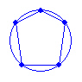

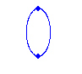

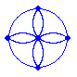 **D E**

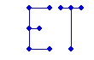

**Question 5 (1 mark)**

Which of the following is a bipartite graph?

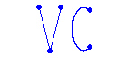**A B C**

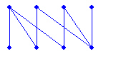

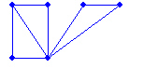**D E**

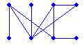

**Question 6 (1 mark)**

How many edges would a complete graph have if it contained 11 vertices?

**A** 55 **B** 66 **C** 110 **D** 121 **E** 132

**Question 7 (1 mark)**

The following graph diagram represents tennis games which were played over one day. Which opponent(s) did person A play?

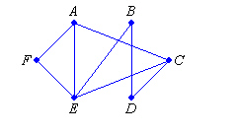

**A** *E, F* **B** *B, F* **C** *B, E, F* **D** *C, E, F* **E** *C, D, E, F*

**Question 8 (1 mark)**

Show two routes that Helen can use to get from *E* to *C*, using the one-way streets as marked, and not returning to *E* on the way.

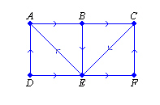

**A** *E-C* and *E-B-C* **B** *E-C* and *E-F-C* **C** *E-C* and *E-A-B-C*

**D** *E-B-C* and *E-F-C* **E** *E-F-C* and *E-A-B-C*

**Question 9 (1 mark)**

|  |  |
| --- | --- |
|  | Represent the following graph using an adjacency matrix. Both rows and columns should be in the order *A* to *F*, from left to right and from top to bottom. |

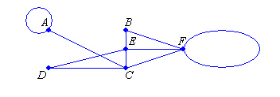

**A B C D E**

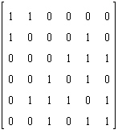

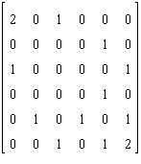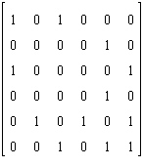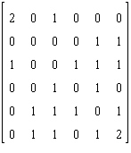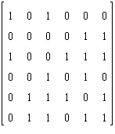

**Question 10 (1 mark)**

A planar graph has 7 vertices and 9 edges. How many faces must it have?

**A**  2 **B** 3 **C** 4 **D** 5 **E** 6

**Question 11 (1 mark)**

Which of the following is an Eulerian graph?

**A B C D E**

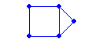  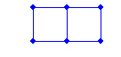 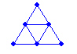 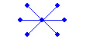

**Question 12 (1 mark)**

Which of the following is a semi-Eulerian graph?

**A B C D E**

 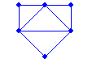 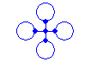 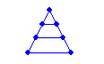 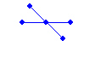

**Question 13 (1 mark)**



Calculate the degree of vertex *P*.

**A** 1 **B** 2 **C** 3 **D** 4 **E** 5

**Question 14 (1 mark)**



Calculate the degree sum of the graph below.

**A** 7 **B** 8 **C** 14 **D** 15 **E** 16